

FALL SEMESTER 2025-2026

VITYARTHI PROJECT

NAME: SAANVI AWASTHI

REGISRATION NUMBER: 25BCE10478

CLASS CODE: CSE1021

PROBLEM STATEMENT

Creating a Tic Tac Toe game setup in python which basically means building a interactive console game.

OBJECTIVE
The goal of this project is to build a full Tic Tac Toe game in Python. The main focus is to design an engaging interface for two players to play against each other. This project also acts as a hands-on example of basic coding skills, such as control flow and handling user input.

OUTCOME

The Tic-Tac-Toe project was effectively completed and achieved its goal of a working fully functional two-player game that was made using Python. At its conclusion, we confirmed the learning goals related to programming, including game logic/representation of the state of the board game (in this case, a 3x3 matrix), turn-taking, and input handling. Most importantly, the logic of the project allows for sophisticated win-condition logic, meaning that horizontal, vertical, and diagonal wins are detected, as well as the condition of a "Draw" or "Cat's Game" if the board is full.

REQUIREMENT ANALYSIS

We require:
- Python
- Microsoft Windows 10 Home Single Language
- Version 10.0.19045 Build 19045
- System Model Inspiron 5570
- System Type x64-based PC
- System SKU 0810
- Processor Intel(R) Core(TM) i5-8250U CPU @ 1.60GHz, 1800 Mhz, 4 Core(s), 8 Logical Processor(s)
- BIOS Version/Date Dell Inc. 1.14.0, 06-04-2023
- SMBIOS Version 3.0
- Embedded Controller Version 255.255

PROBLEM DEFINITION

TIC TAC TOE - Write a Python program that allows two players to play the classic game of Tic Tac Toe on a 3x3 grid. The players - one playing as 'X' and the other as 'O' - take turns to input their moves. The system is to validate each move, update the board, and present the current state after every turn. The program should automatically check for winning conditions-three matching symbols in a row, column, or diagonal-or a draw-if the board is full and there's no winner-and declare the result accordingly. Input validation and error handling in case of invalid or repeated moves are necessary for smooth gameplay.

ALGORITHM

Step 1: Start.

Step 2: Initialize Game
• Create a 3x3 board with empty cells.
• Set the starting player as 'X'.

Step 3: Repeat Until Game Ends
o Print the current state of the board.
o Get valid move input (row, column) from the current player.
o Place the player’s symbol in the chosen cell.
o Check for a winner:
o If the current player has filled a row, column, or diagonal, declare them the winner and end the game.
o If there is no winner, check for a draw:
o If all cells are filled and there is no winner, declare a draw and end the game.
o If the game is still ongoing, switch to the other player ('X' or 'O').

Step 4: Game Ends
• Announce the winner or draw, and display the final state of the board.
This algorithm clearly outlines your program logic and follows the standard Tic Tac Toe gameplay structure.

Step 5: Stop.

WORKFLOW DIAGRAM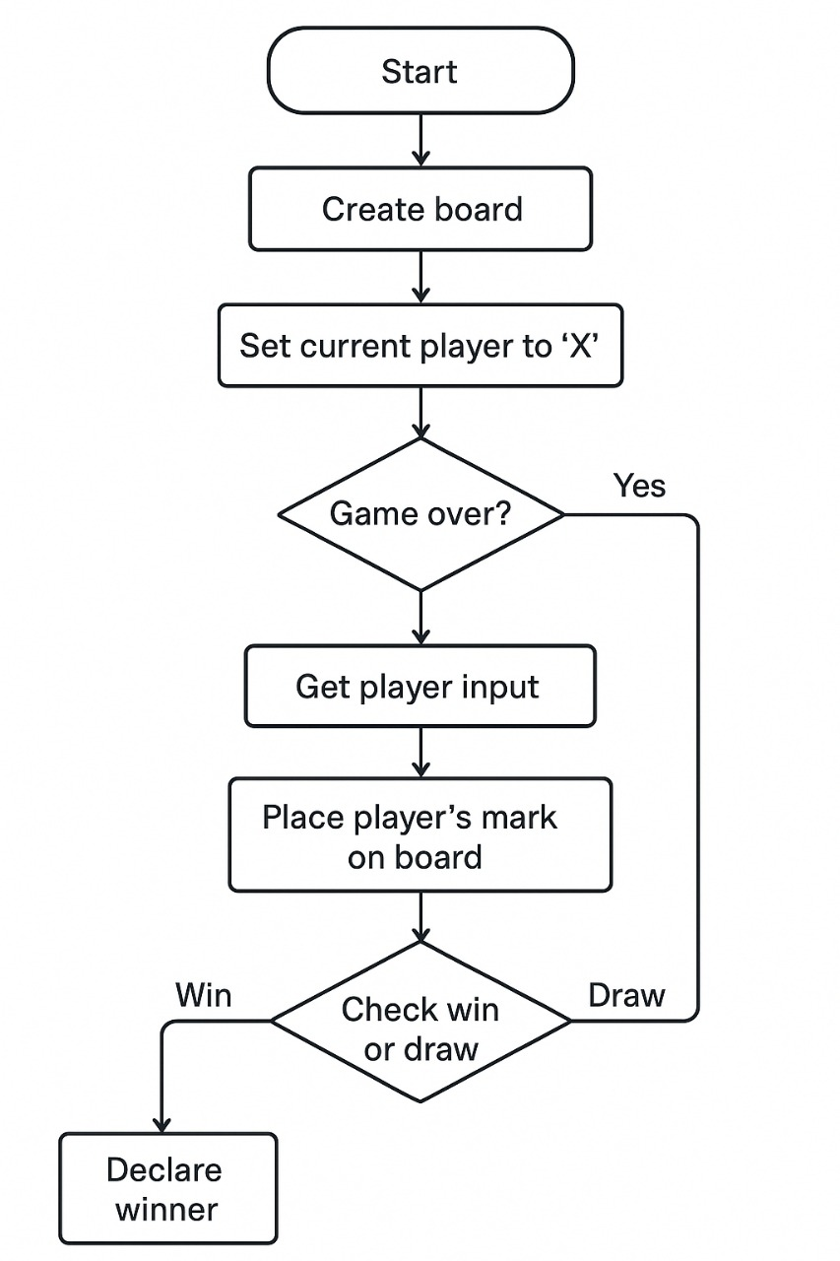

IMPLEMENTATION

Code:
def create_board():

return [
[' ', ' ', ' '],
[' ', ' ', ' '],
[' ', ' ', ' ']
]

def print_board(board):
print("\n 0 1 2")
for i, row in enumerate(board):

print(f"{i} " + " | ".join(row))
if i < 2:
print(" ---|---|---")
print()

def check_win(board, player):
for r in range(3):
if all(board[r][c] == player for c in range(3)):
return True

for c in range(3):
if all(board[r][c] == player for r in range(3)):
return True

if all(board[i][i] == player for i in range(3)):
return True

if all(board[i][2 - i] == player for i in range(3)):
return True

return False

def check_draw(board):

for r in range(3):
for c in range(3):
if board[r][c] == ' ':
return False

return True

def get_player_input(player, board):

while True:
user_input = input(f"Player '{player}', enter move (row col): ")
parts = user_input.split()

if len(parts) != 2:
print("Invalid input. Please enter TWO numbers separated by a space.")
continue

row_str, col_str = parts

if not (row_str.isdigit() and col_str.isdigit()):
print("Invalid input. Please enter NUMBERS for row and col.")
continue

row = int(row_str)
col = int(col_str)

if not (0 <= row <= 2 and 0 <= col <= 2):
print("Coordinates out of range. Must be 0, 1, or 2.")
continue

if board[row][col] != ' ':
print("That cell is already taken! Try again.")
continue

return row, col

def play_game():

print("--- Welcome to Tic-Tac-Toe! ---")

board = create_board()
current_player = 'X'
game_over = False

while not game_over:

print_board(board)

row, col = get_player_input(current_player, board)

board[row][col] = current_player

if check_win(board, current_player):
print_board(board)
print(f"🎉 Player '{current_player}' wins! Congratulations!")
game_over = True

elif check_draw(board):
print_board(board)
print("It's a draw! 🤝")
game_over = True

else:
current_player = 'O' if current_player == 'X' else 'X'

if __name__ == "__main__":
play_game()

TESTING APPROACH

1. Unit Testing:

• Board Initialization:

Test whether a new board object is created with the default state as an empty 3x3 grid.

• Make a Move:

Test placing markers (X or O) in positions on the board and verify that it updates the state of the board correctly. Handle invalid moves such as placing in an already occupied cell or outside the boundaries of the board.

• Checking for Winner:

Implement tests for every possible winning condition of both players - rows, columns, and diagonals.

• Draw Check:

Check if the game correctly identifies a draw when all cells have been filled and no winner is found.

• Game State Management:

Test functions that check whether the game is over, whether it is a draw, or if there is a winner.

2. Integration Testing:

• Player Interaction:

If the game involves human players or AI components, test the interaction of the game logic and player input/ AI decisions.

• Game Flow:

Simulate a complete game from start to finish, including scenarios such as a win for X, a win for O, and a draw.

3. Functional Testing:

• *User Interface* (if applicable):

If there's a graphical interface: Test that it accurately reflects the game state and responds correctly to user input.

Gameplay Scenarios:

Perform various gameplay scenarios manually to verify the expected behavior of the game in any of the given conditions: first player wins, second player wins, specific winning patterns, blocking moves.

RESULTS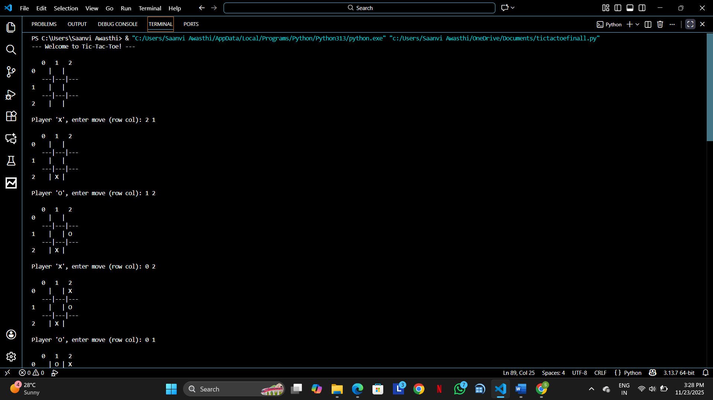

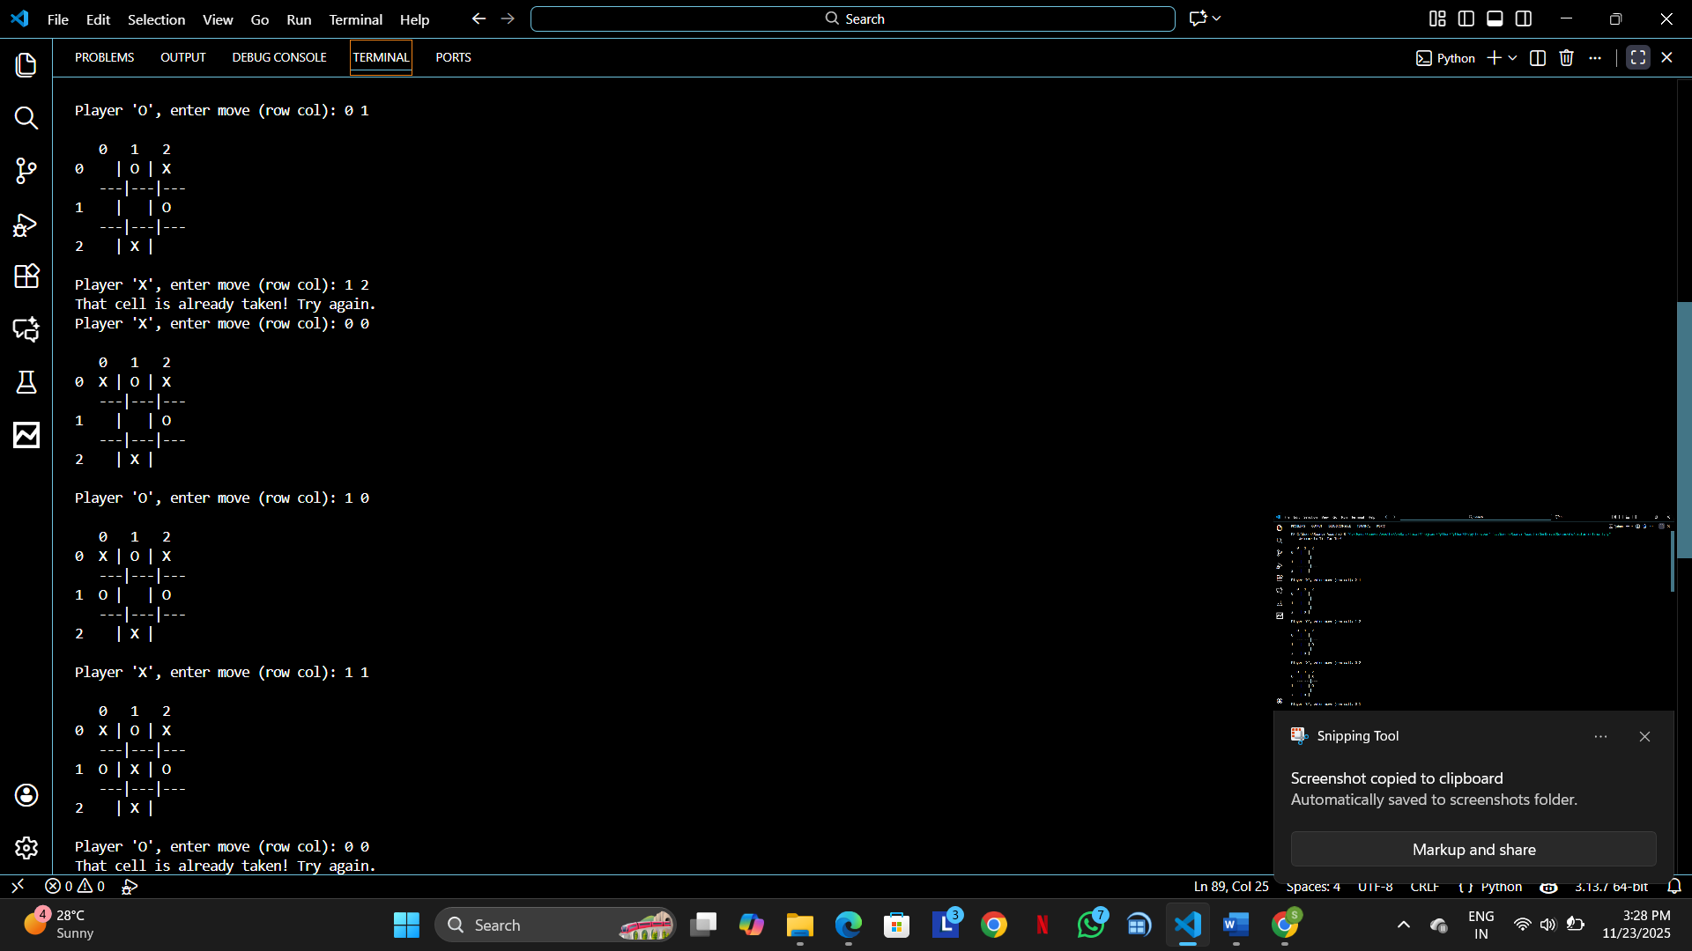

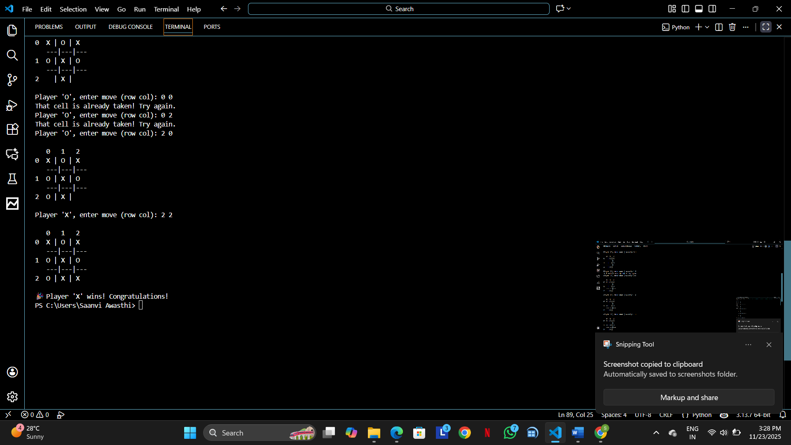

CHALLENGES FACED

During the development of the Tic-Tac-Toe game in Python, several complexities were encountered on the way. First, there was designing the game board using nested lists and checking every move to update the proper position without causing an indexing error. Also, in handling user input, validation had to be done to make sure the values entered were numeric, within range, and not occupied. The implementation of the win-checking logic was also another challenge since this involved checking rows, columns, and both diagonals accurately using loops and conditions. Also, the management of the flow of the whole game-switching players, checking for draws, and not going into any infinite loops-required quite clear understanding of control structures. All these challenges helped solidify concepts such as loops, conditionals, functions, and data validation that were crucial in producing this functional-and user-friendly.

